Aprimo.SecurityImporter Tool Usage Notes

This tool will be able to import:

* User groups
* Functional DAM Permissions
* Classification Permissions

The import is based on Excel file generated by running tool Aprimo.SecurityExporter.

It is advisable to clean up exported Excel document before importing, by leaving in it only information relevant for import (e.g. if not all user groups that were imported should be reimported into destination environment, then remove the columns/rows from export file that contain information for this user group).

The interface of the tool is as pictured:

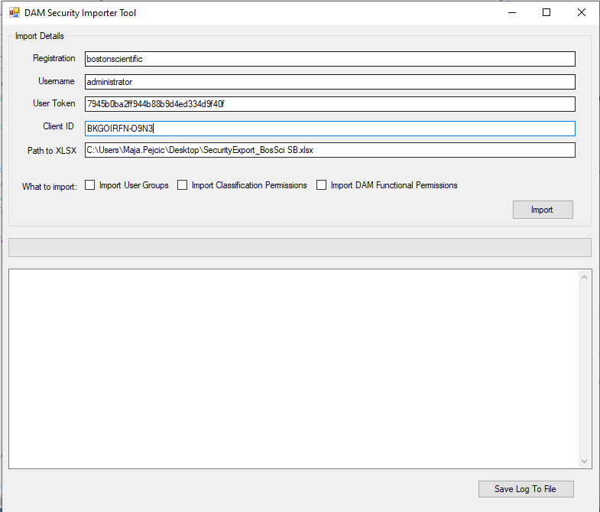

For running the tool, you will need following input information:

* Registration/domain of destination environment
* Username for the user who is running the import. For the import to be successful, that needs to be user with system administration privileges.
* User Token – generate user token if not generated already, instructions are given here:

<https://developers.aprimo.com/marketing-operations/rest-api/authorization/>

* Client ID – generate client if not generated already, instructions are given here: <https://developers.aprimo.com/marketing-operations/rest-api/authorization/>
* Path to Excel file produced by Exporter tool

Select which import to run. If User Groups have not been imported already and you would like to import permissions for those groups, in the first run import User Groups only, then run import for Functional and Classification permissions.

Tool will show you progress via progress bar and logs. Logs can be saved in a text file using “Save Log To File”.

In case you need to modify permissions in the Excel document before you import, that can be done manually. Please keep in mind that appropriate values that you need to use for certain permissions within the spreadsheet are different than the values you might see in DAM UI. Table below gives overview:

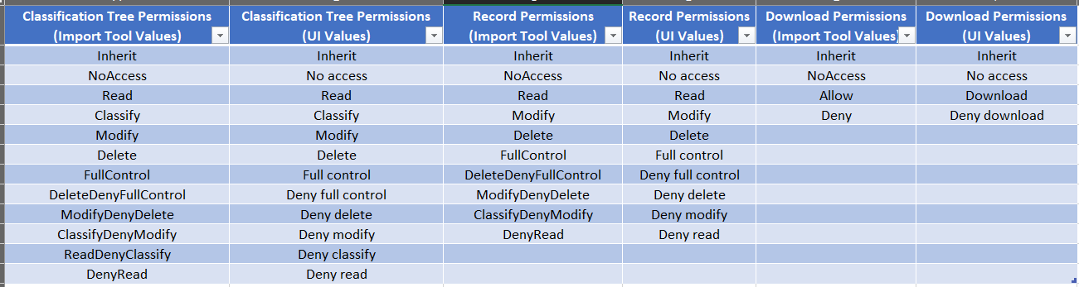

# Important tool restrictions and gotchas

* When importing user groups from one environment to another, make sure your excel spreadsheet for import contains all these columns and in this order:
  + User Group ID, User Group Name, DAM User Group ID, Status, Finance Group, Description, Domain Rights
  + Note that sometimes when you export user groups from one environment, if there were not Descriptions for those user groups, the spreadsheet from export won’t contain Description column, but it is necessary (even if it’s empty!) for correct import.
* Never import user groups or permissions for OOTB DAM groups (such as DAM Administrators, DAM Operators etc) or PM groups. Clean up exported Excel (by deleting unnecessary rows/columns) before importing
* Note that when importing user groups, if user group existed on destination environment, users associated with that user group would get removed. Always import only net new groups only.